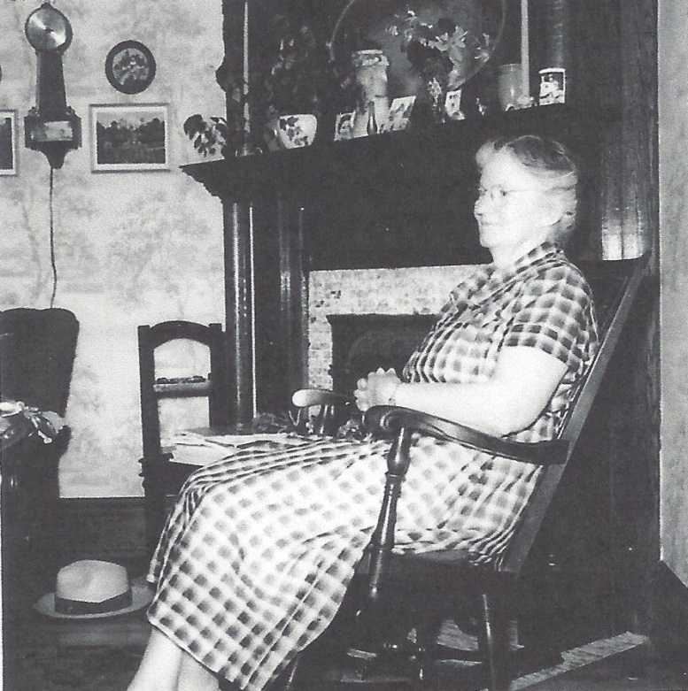

**Josephine Sybil Worthen Wolfe – Kingston – 1954**

**Earl Russell and Josephine Sybil Worthen Wolfe Family**

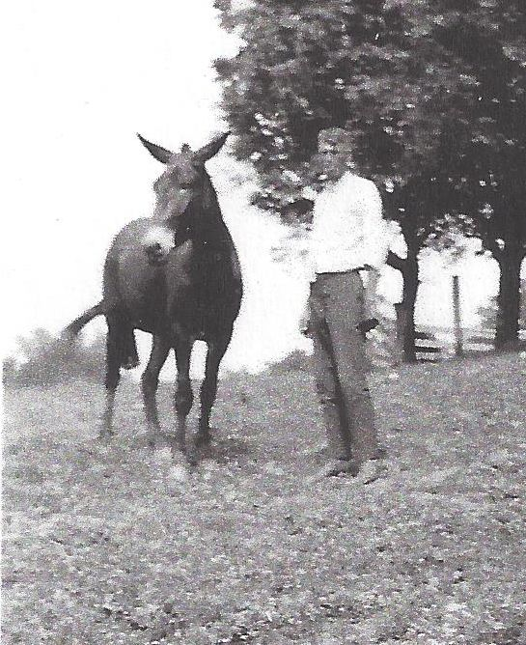

**Earl Russell Wolfe – about 1915 (est.)**